1. **Code**

<https://github.com/daizhaohui/abc-demo>

git clone <https://github.com/daizhaohui/abc-demo.git>

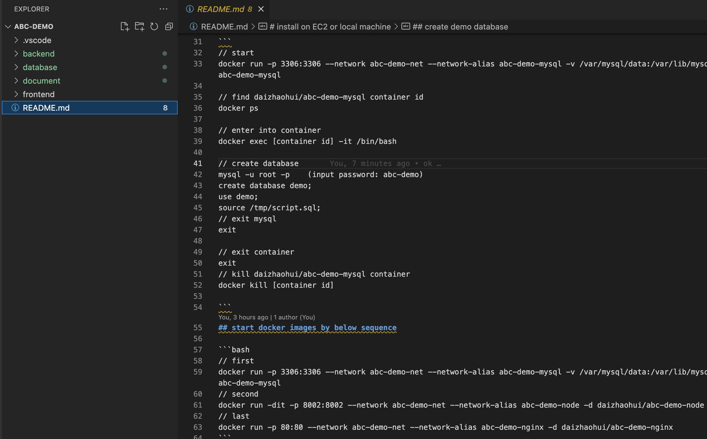

* Frontend

vue3+ typescript + jest

reference framework: <https://github.com/daizhaohui/lincy-vue>, <https://github.com/daizhaohui/lincy-js-utils>, <https://github.com/daizhaohui/lincy-docs>

* Backend

nest + typescript + typeorm + jest

* Databse

Mysql

* Deploy

docker,

|  |  |
| --- | --- |
|  | docker image address |
| Fronend | https://hub.docker.com/repository/docker/daizhaohui/abc-demo-nginx |
| Backend | https://hub.docker.com/repository/docker/daizhaohui/abc-demo-node |
| Database | https://hub.docker.com/repository/docker/daizhaohui/abc-demo-mysql |

1. demo screen shot

picture query

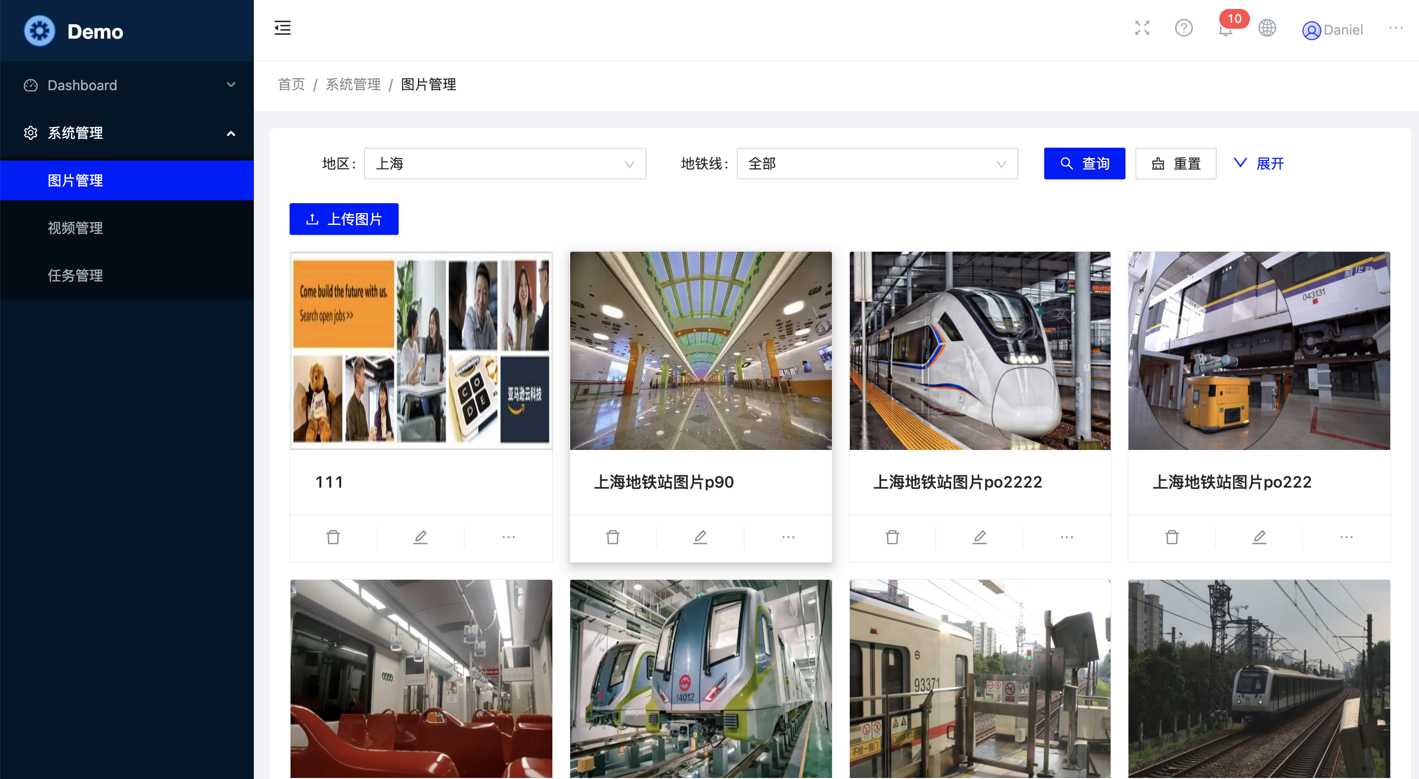

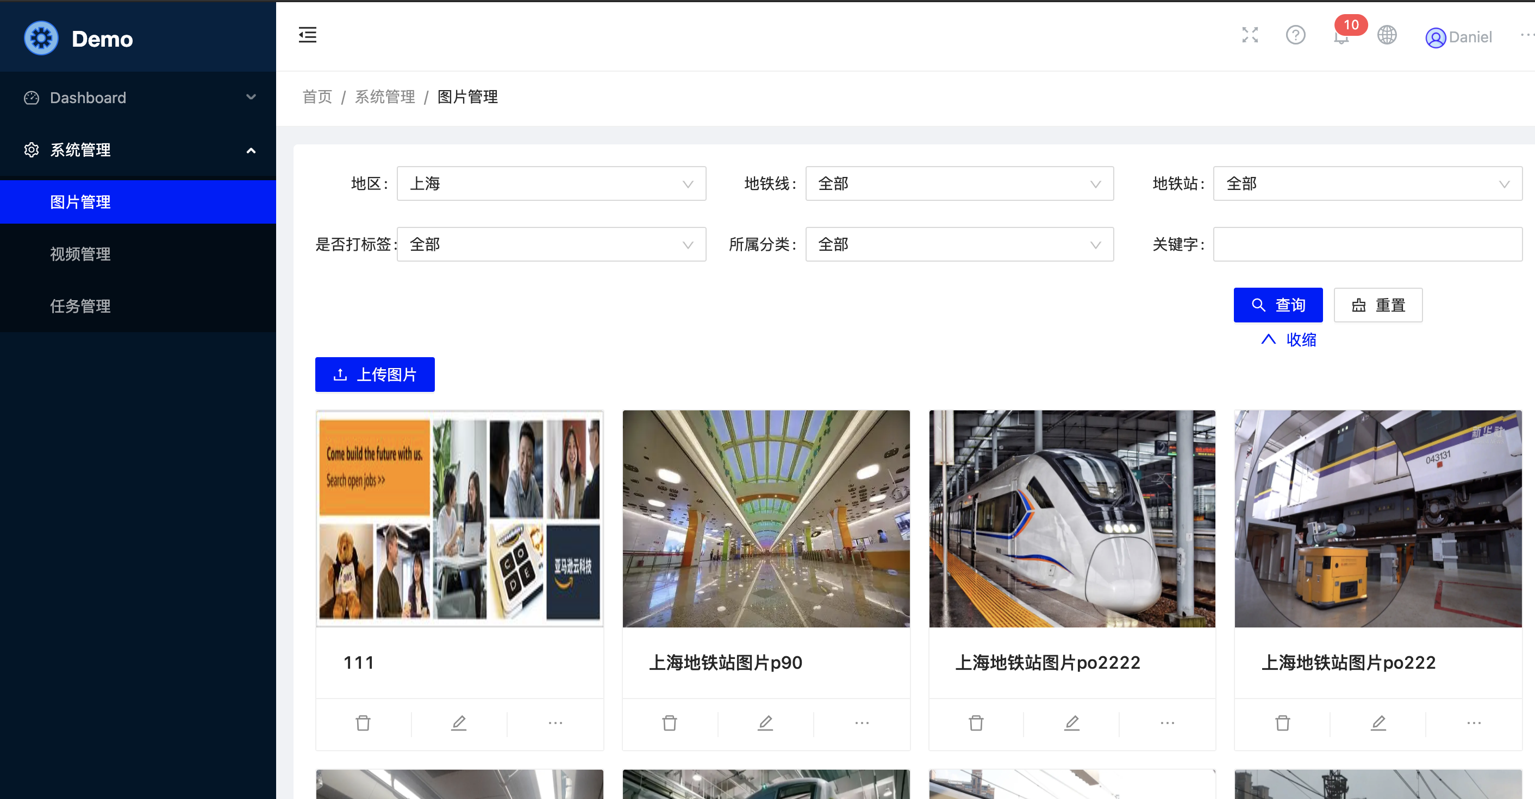

upload picture to S3

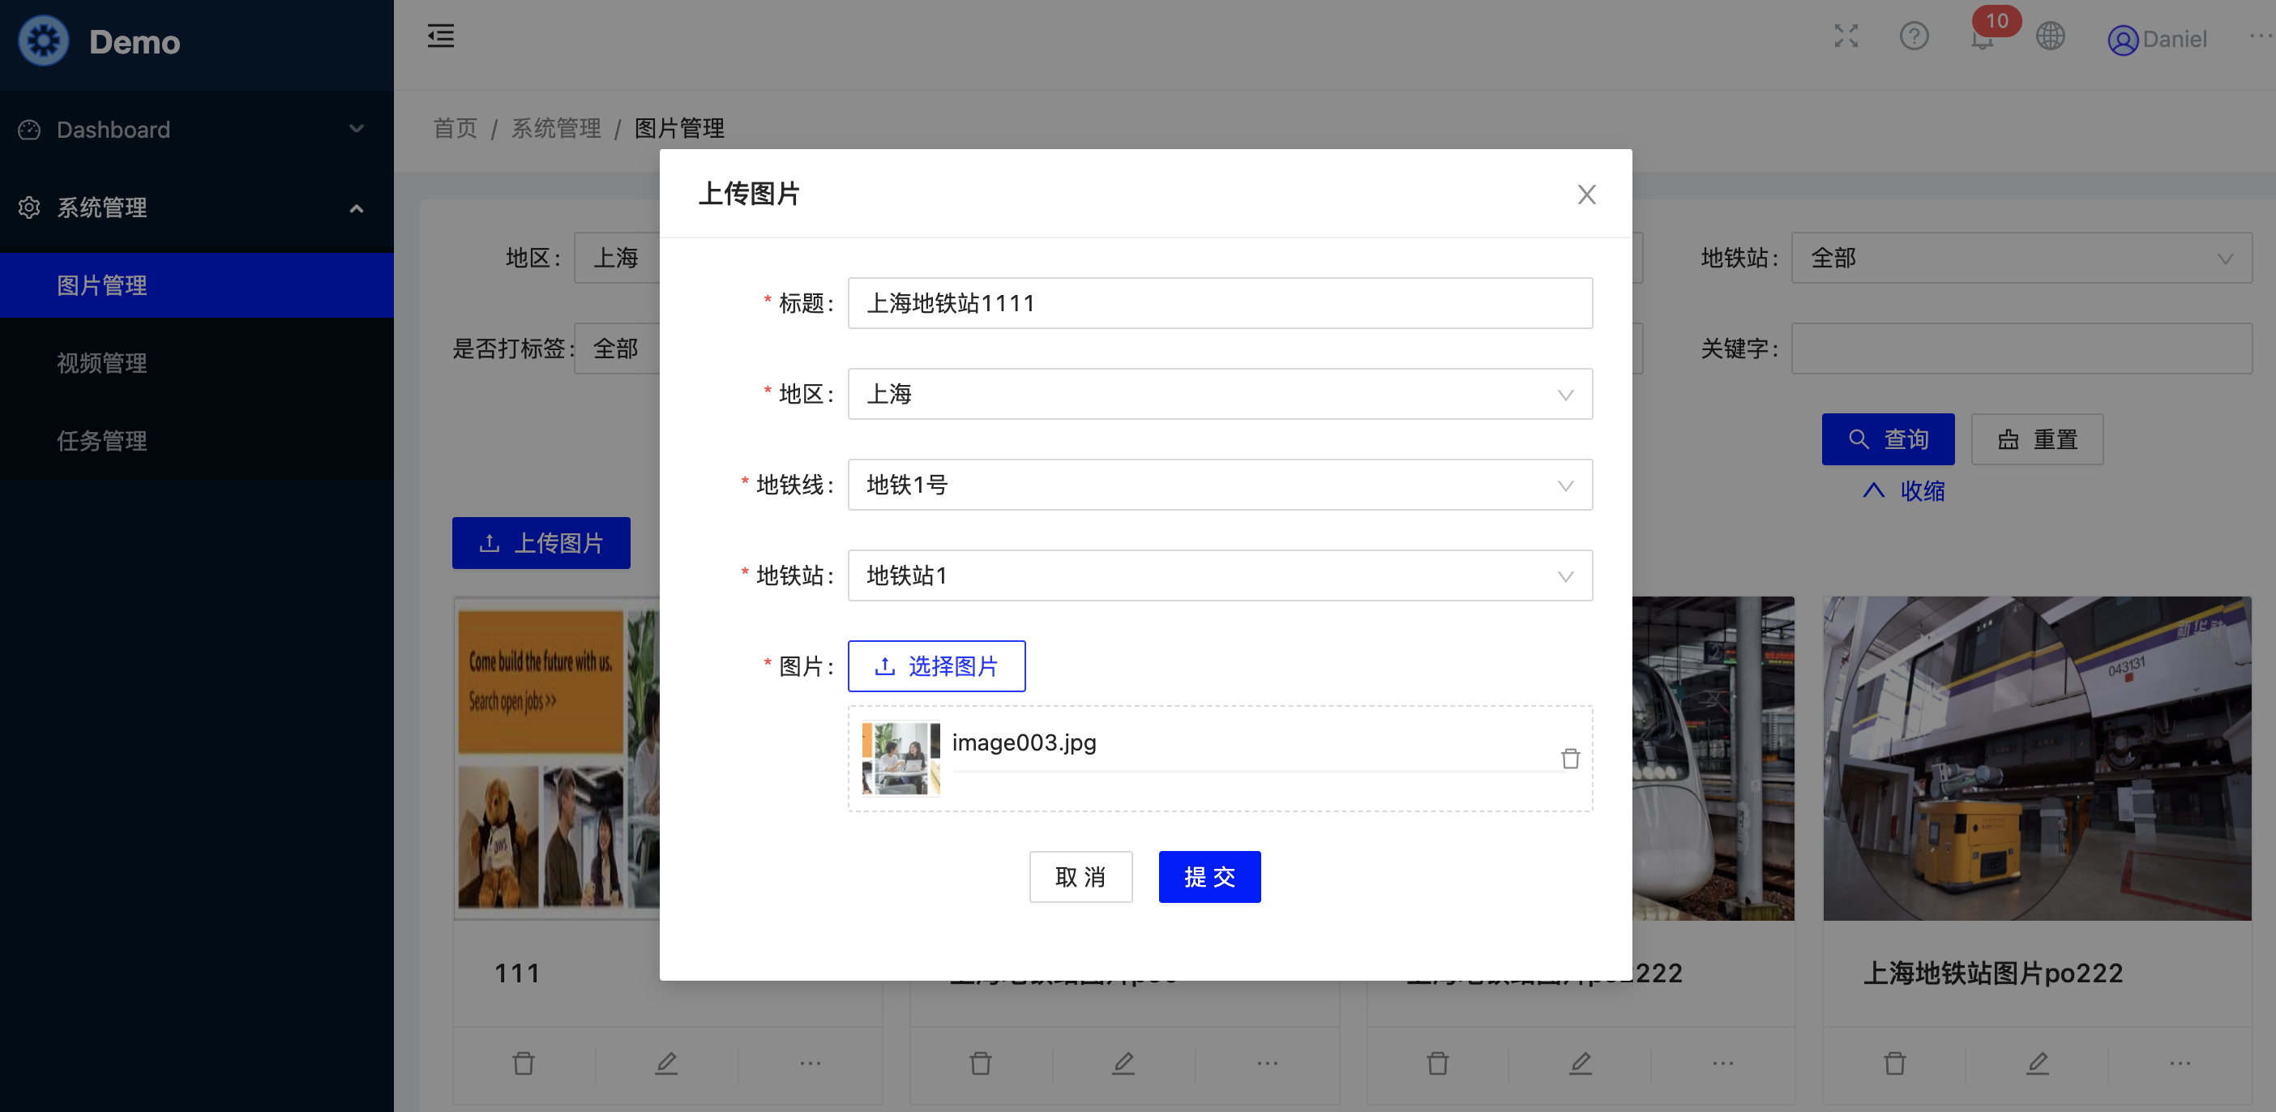

Label picture

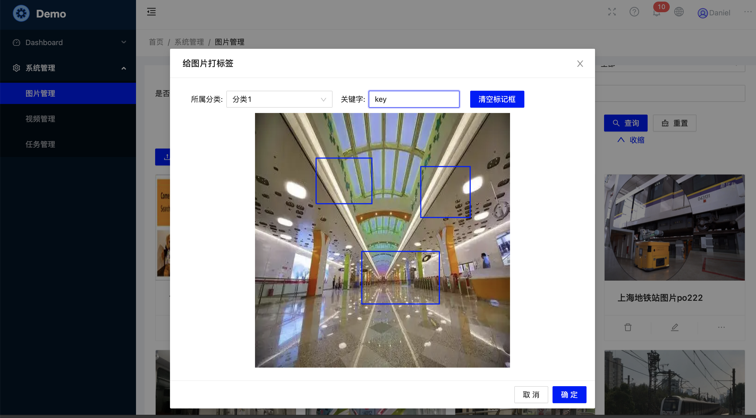

Video query

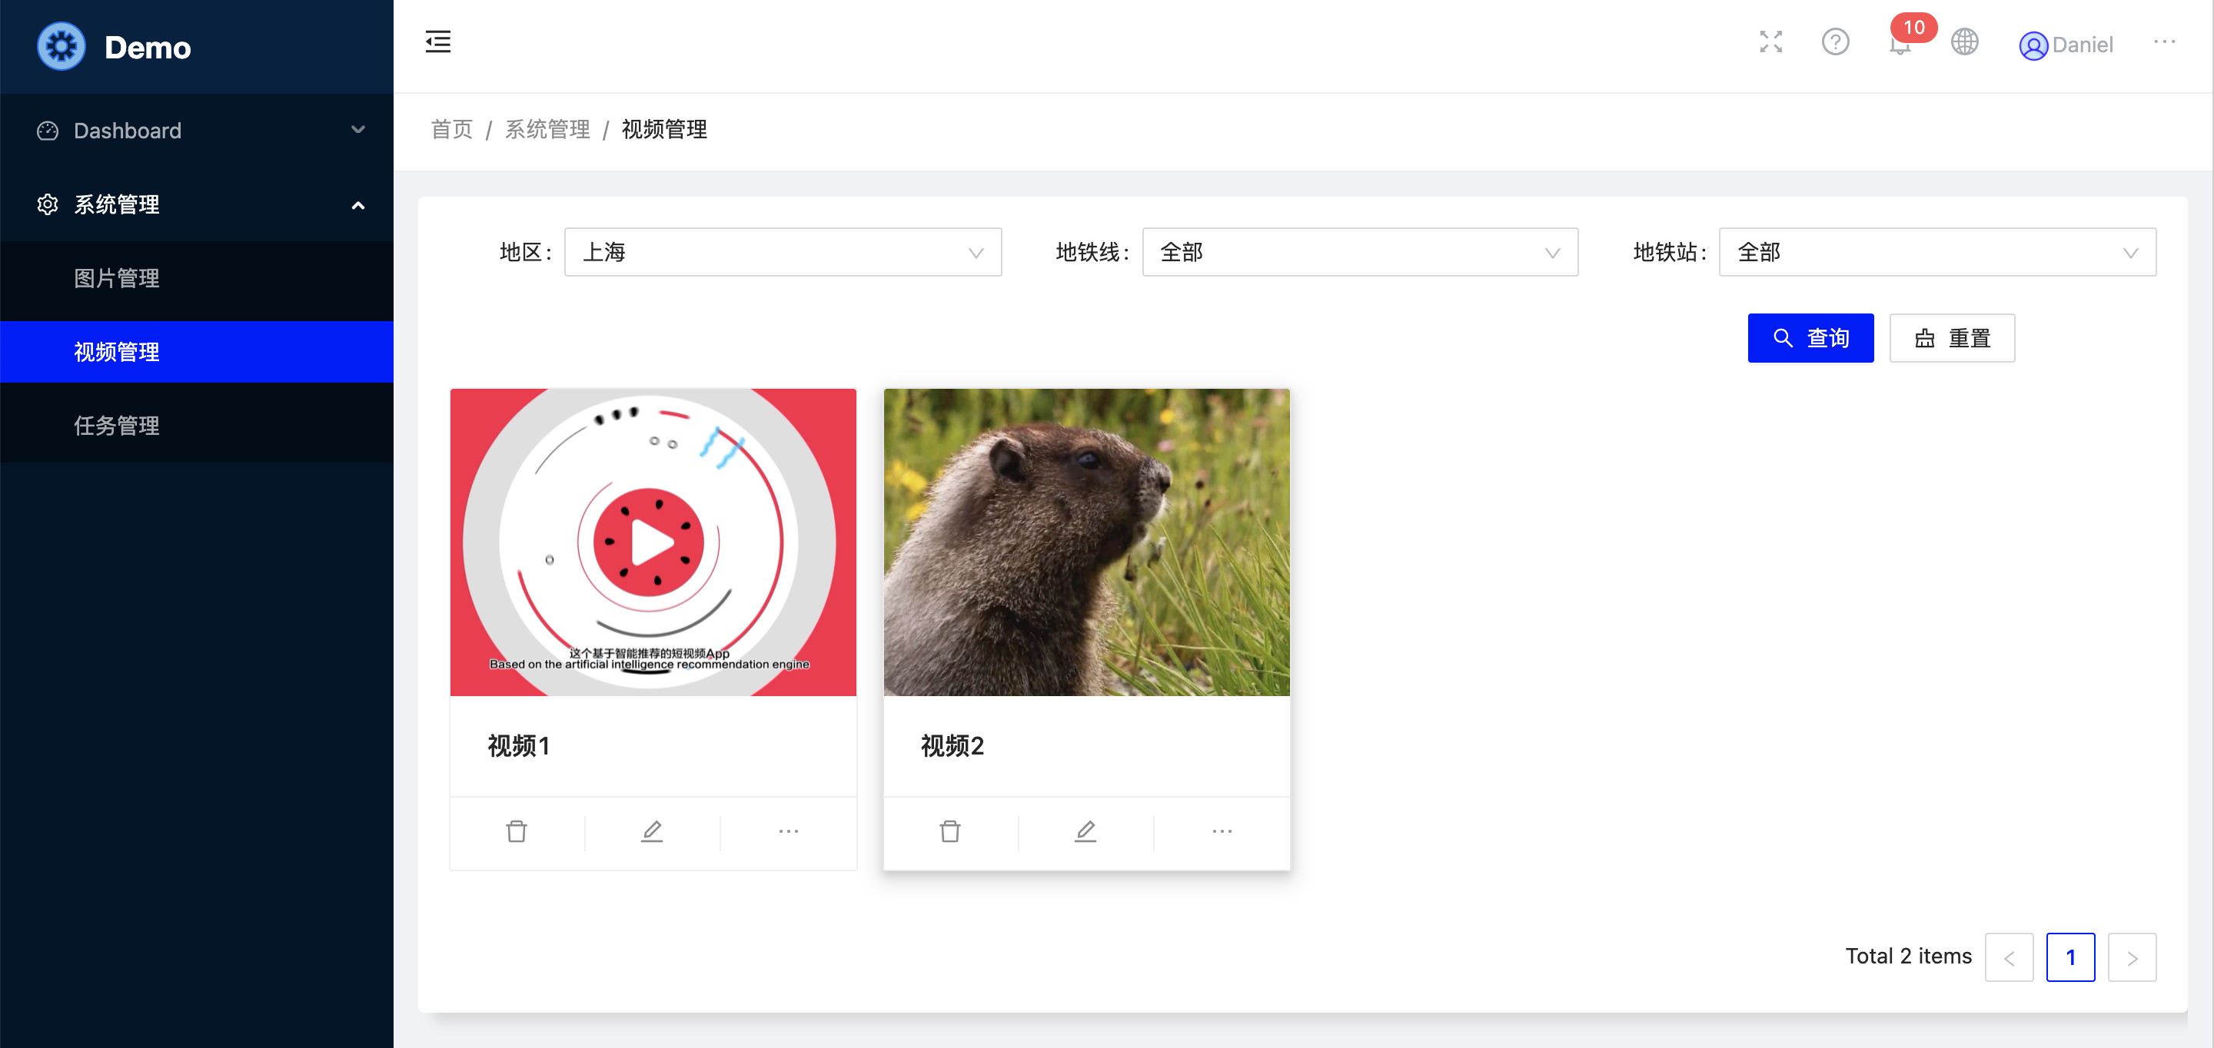

Paly video

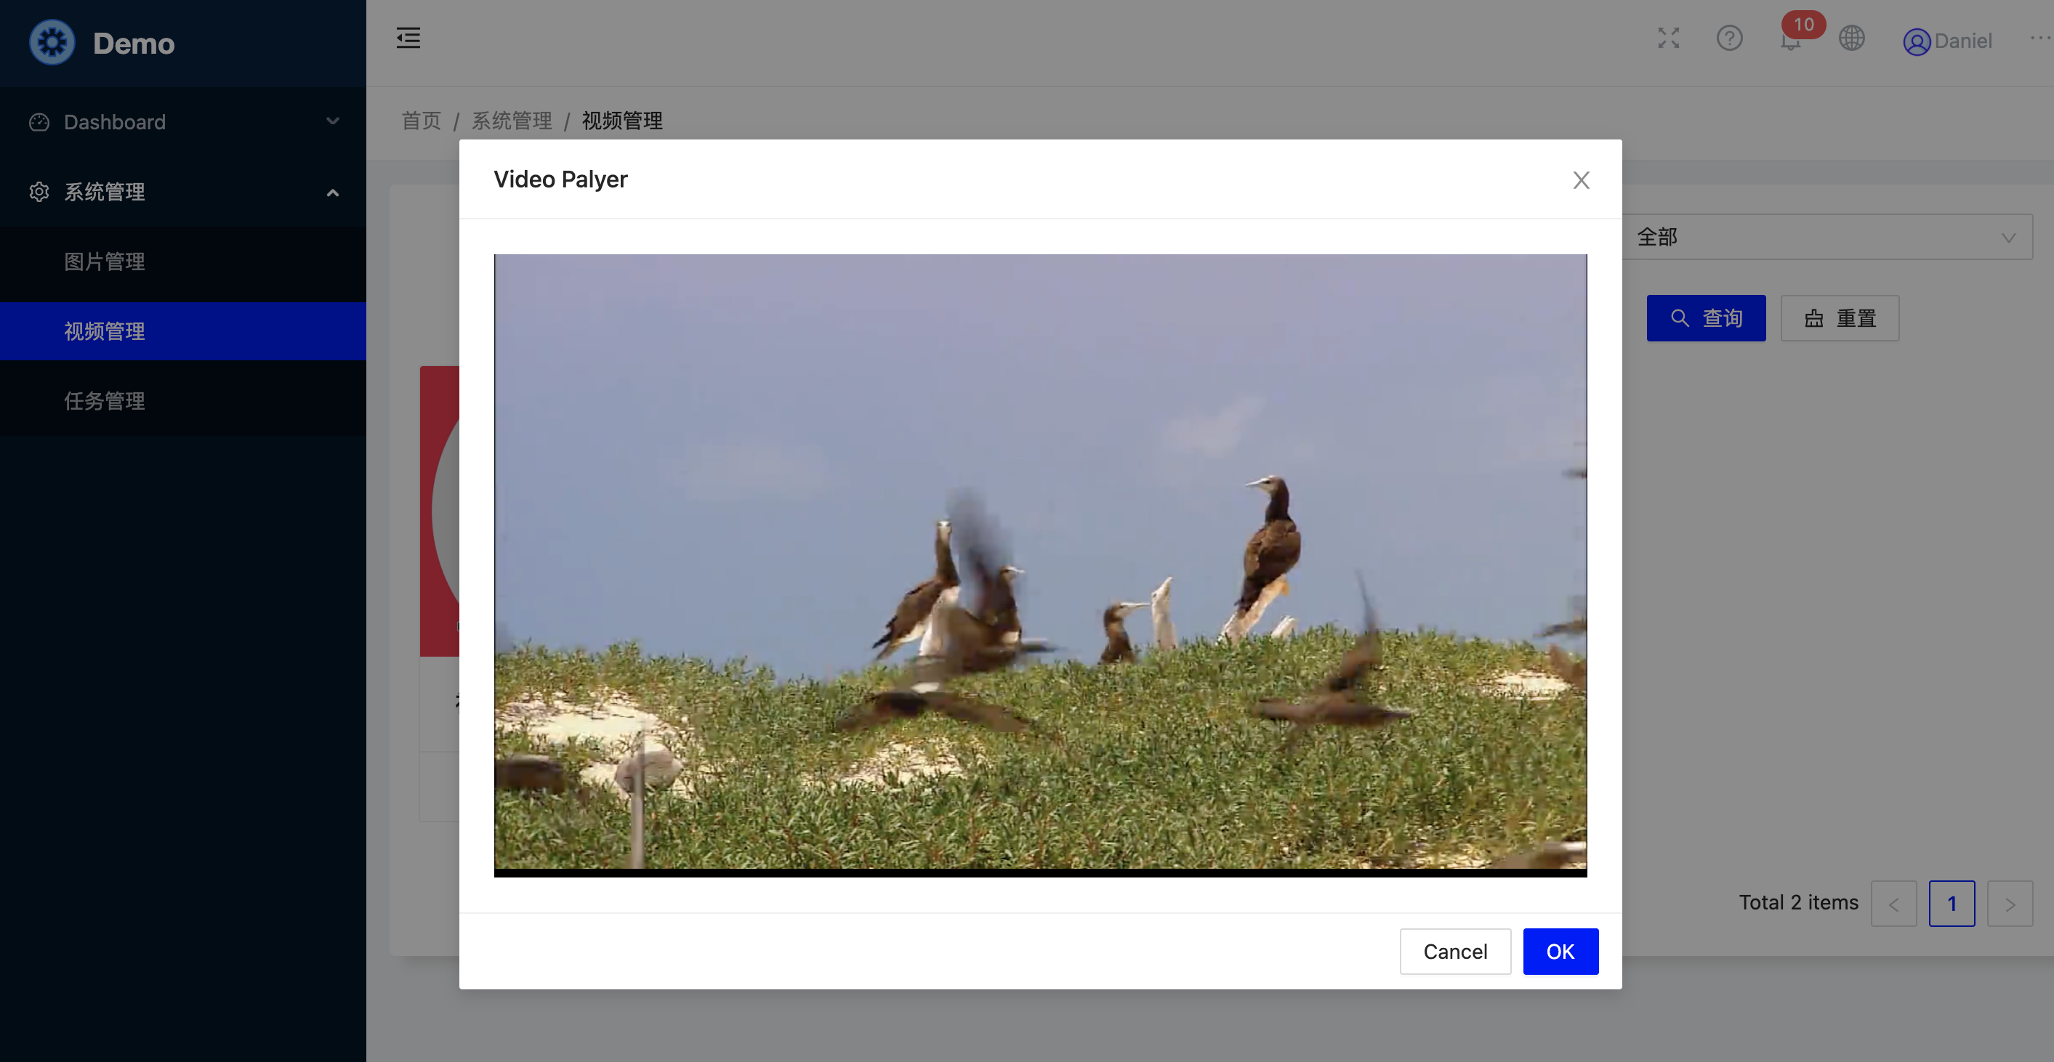

task status

